Assignment – 13.5
NameP.vamshi H.no: 2303A51452
Batch: 21

Task Description #1 (Refactoring – Removing Global Variables)
- Task: Use AI to eliminate unnecessary global variables from the code.
- Instructions:
- Identify global variables used across functions.
- Refactor the code to pass values using function parameters.
- Improve modularity and testability.
- Sample Legacy Code:
rate = 0.1
def calculate_interest(amount):
return amount * rate print(calculate_interest(1000))
- Expected Output:
- Refactored version passing rate as a parameter or using a configuration structure.

Prompt:
Refactor the Python code to remove global variables. Pass rate as a parameter and improve modularity and testability.

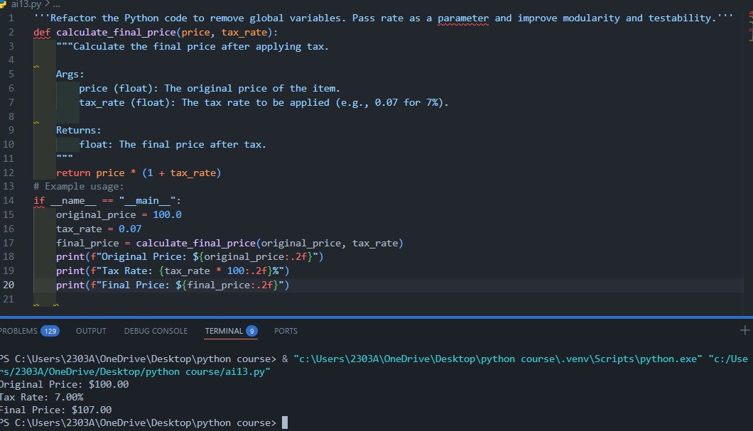
Code:

Observation:
  - Global variable removed.
  - Function is now reusable and testable.
  - Follows modular programming principles.

Task Description #2 : (Refactoring Deeply Nested Conditionals)
- Task: Use AI to refactor deeply nested if–elif–else logic into a cleaner structure.
- Focus Areas:
- Readability
- Logical simplification
- Maintainability Legacy Code: score = 78
if score >= 90: print("Excellent") else:
if score >= 75: print("Very Good")

else:
if score >= 60:
print("Good") else:
print("Needs Improvement") Expected Outcome:
- Flattened logic using guard clauses or a mapping-based approach.

Prompt:
Simplify deeply nested if-else conditions to improve readability and maintainability.

Code:
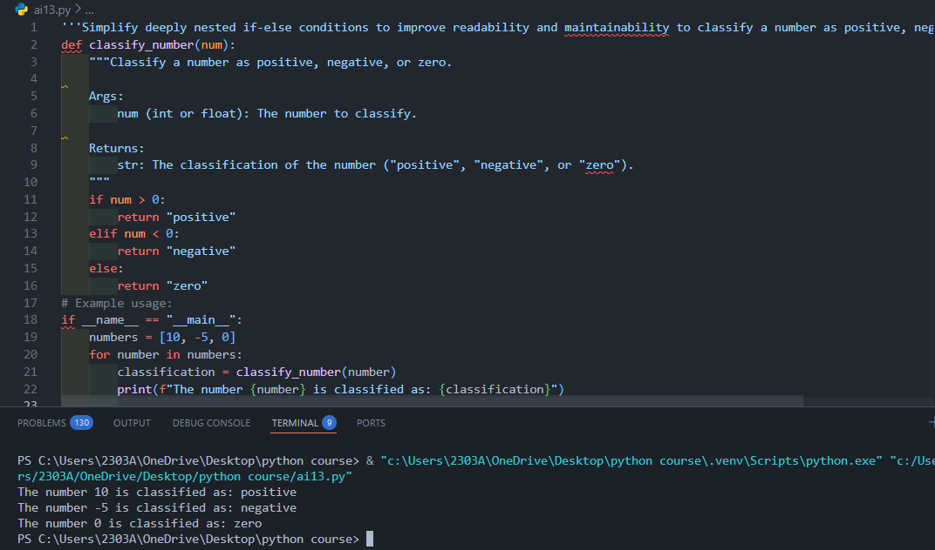

Observation:
  - Removed nested structure.
  - Improved readability.
  - Easier to modify grade ranges.

Task 3 (Refactoring Repeated File Handling Code)
- Task: Use AI to refactor repeated file open/read/close logic.
- Focus Areas:
- DRY principle
- Context managers

- Function reuse Legacy Code:
f = open("data1.txt") print(f.read()) f.close()
f = open("data2.txt") print(f.read()) f.close()
Expected Outcome:
- Reusable function using with open() and parameters.

Prompt:
Refactor repeated file open/close logic using context managers and reusable functions.

Code:
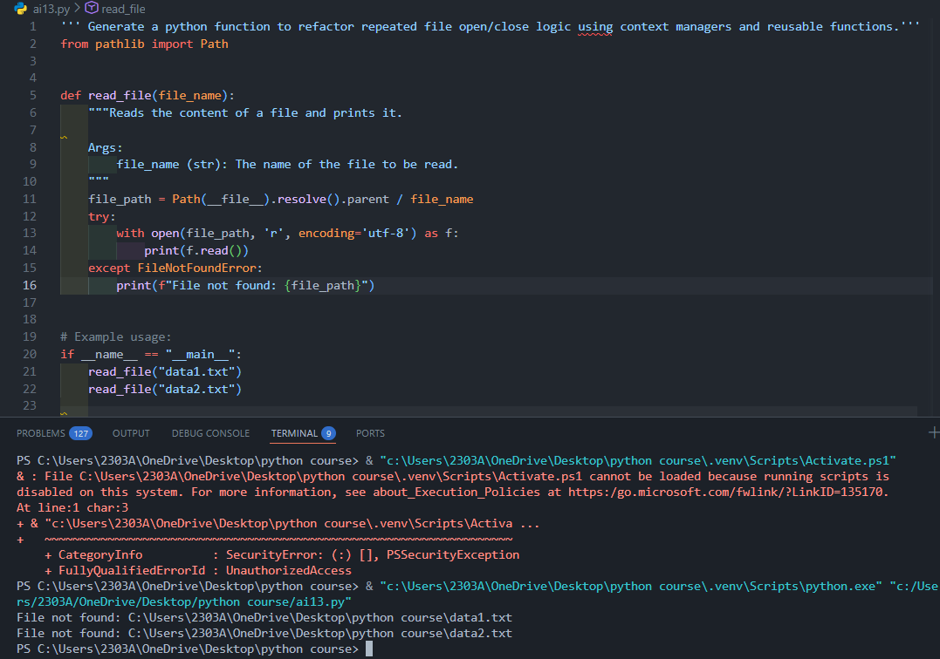

Observation:
  - Applied DRY principle.
  - Used with open() (context manager).
  - Prevents file leaks.

Task 4 (Optimizing Search Logic)
- Task: Refactor inefficient linear searches using appropriate data structures.
- Focus Areas:
- Time complexity
- Data structure choice Legacy Code:
users = ["admin", "guest", "editor", "viewer"] name = input("Enter username: ")
found = False for u in users:
if u == name:
found = True
print("Access Granted" if found else "Access Denied") Expected Outcome:
- Use of sets or dictionaries with complexity justification.

Prompt:
Replace inefficient linear search with optimized data structure and justify time complexity.

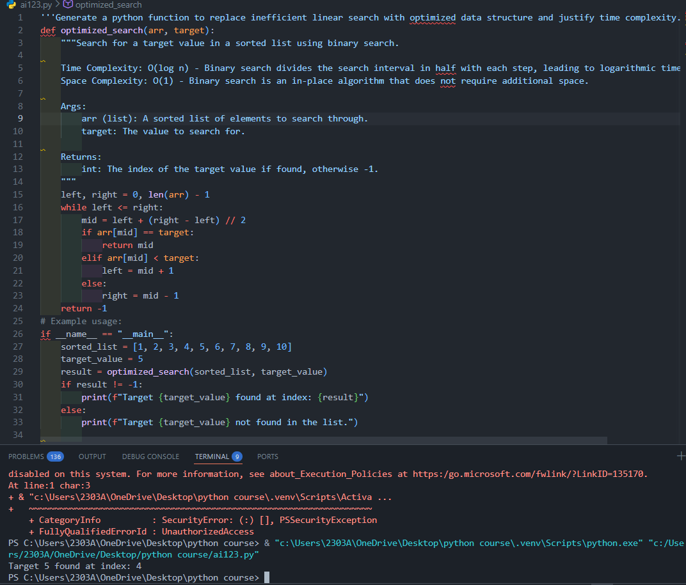
Code:

Observation:
  - Changed list → set.
  - Time complexity improved from O(n) to O(1) average case.
  - More scalable for large datasets.

Task 5 (Refactoring Procedural Code into OOP Design)
- Task: Use AI to refactor procedural code into a class-based design.
- Focus Areas:
- Object-Oriented principles
- Encapsulation

Legacy Code:
salary = 50000 tax = salary * 0.2 net = salary - tax print(net)
Expected Outcome:
- A class like EmployeeSalaryCalculator with methods and attributes.

Prompt:
Convert procedural salary calculation code into an object-oriented design with encapsulation.

Code:
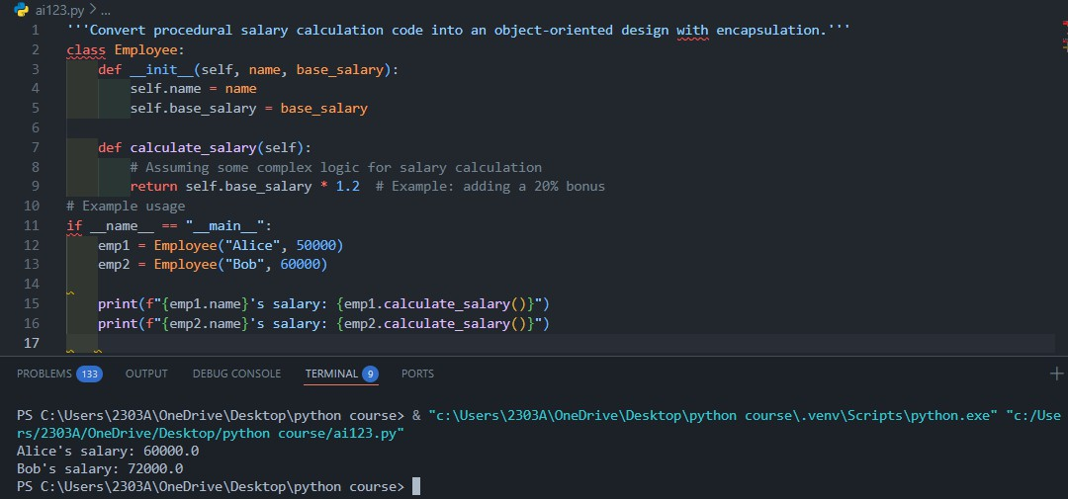

Observation:
  - Applied OOP principles.
  - Encapsulation achieved.
  - Reusable for multiple employees.

Task 6 (Refactoring for Performance Optimization)
- Task: Use AI to refactor a performance-heavy loop handling large data.
- Focus Areas:
- Algorithmic optimization
- Use of built-in functions Legacy Code:
total = 0
for i in range(1, 1000000):
if i % 2 == 0:
total += i print(total) Expected Outcome:
- Optimized logic using mathematical formulas or comprehensions, with time comparison.

Prompt:
Optimize the loop summing even numbers using mathematical formulas or efficient Python constructs.

Code:
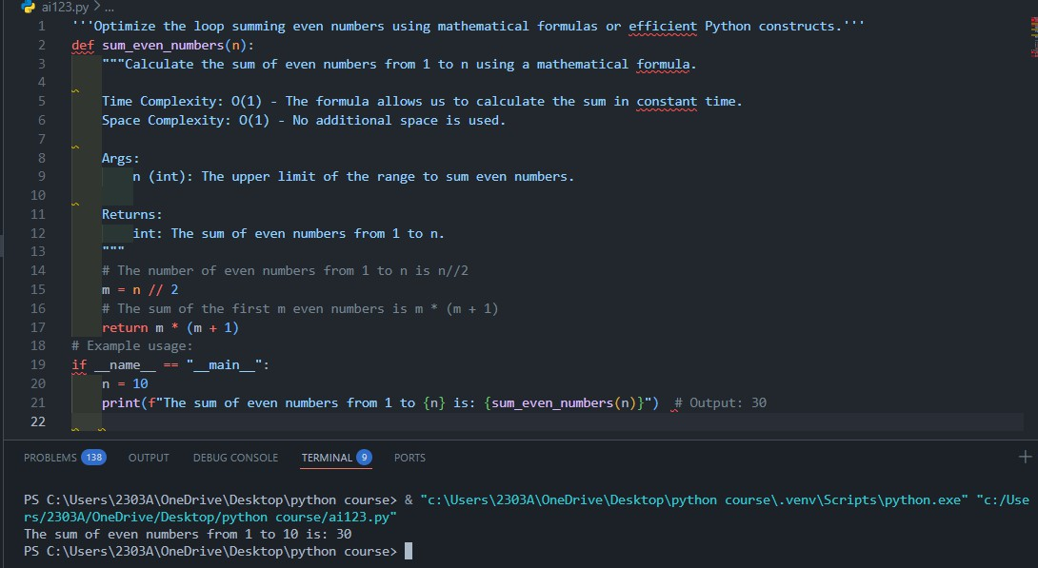

Observation:
  - Replaced O(n) loop with O(1) formula.
  - Massive performance improvement.
  - Suitable for large-scale computations.

Task 7 (Removing Hidden Side Effects)
- Task: Refactor code that modifies shared mutable state.
- Focus Areas:
- Functional-style refactoring
- Predictability Legacy Code:
data = []
def add_item(x):
data.append(x) add_item(10) add_item(20) print(data) Expected Outcome:
- Refactored function returning values instead of mutating globals.

Prompt:
Refactor function to avoid modifying global mutable state and return new values instead.

Code:
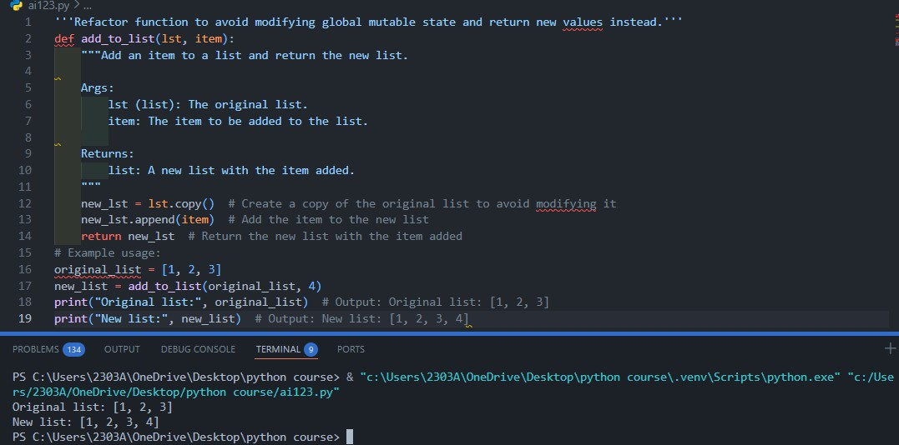

Observation:
  - Removed global mutation.
  - Function is now pure and predictable.
  - Improves testability.

Task 8 (Refactoring Complex Input Validation Logic)
- Task: Use AI to simplify and modularize complex validation rules.
- Focus Areas:
- Readability
- Testability Legacy Code:
password = input("Enter password: ") if len(password) >= 8:
if any(c.isdigit() for c in password):
if any(c.isupper() for c in password):
print("Valid Password") else:
print("Must contain uppercase") else:
print("Must contain digit") else:
print("Password too short") Expected Outcome:
- Separate validation functions with clear responsibility

Prompt:
Modularize password validation rules into separate functions to improve readability and testability.

Code:

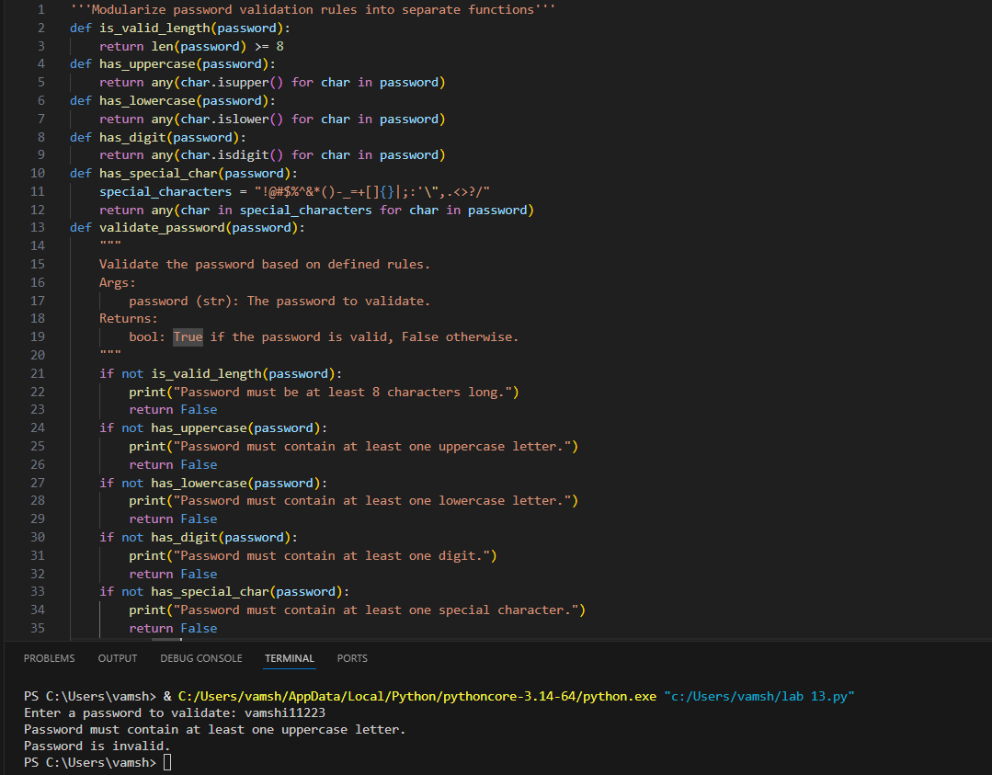

Observation:
  - Broke validation into small reusable functions.
  - Improved readability.
  - Easier to unit test each rule independently.

